Data Structure and Algorithm

Laboratory Activity No. 5

Implementation of Arrays

| *Submitted by:* | *Instructor:* |
| --- | --- |
| Elpedes, Glen Jorge A. | Engr. Maria Rizette H. Sayo |

August, 16, 2025

# Objectives

Introduction

Array, in general, refers to an orderly arrangement of data elements. Array is a type of data structure that stores data elements in adjacent locations. Array is considered as linear data structure that stores elements of same data types. Hence, it is also called as a linear homogenous data structure.

This laboratory activity aims to implement the principles and techniques in:

* Writing algorithms using Array data structure
* Writing a python program that can implement Array data structure

# Methods

* Write a Python program to create an array of 10 integers and display the array items. Access individual elements through indexes and compute for the sum.
* Write a Python program to append a new item to the end of the array. Original array: numbers = [1, 2, 3, 4, 5, 6, 7, 8, 9, 10]
* Write a Python program to insert a new item before the second element in an existing array. Original array: numbers = [1, 2, 3, 4, 5, 6, 7, 8, 9, 10]
* Write a Python program to reverse the order of the items in the array. Original array: numbers = [5, 4, 3, 2, 1]
* Write a Python program to get the length of the array. Original array: numbers = [5, 4, 3, 2, 1]

# Results

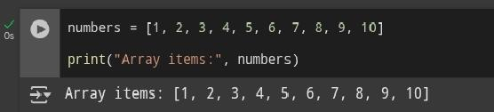

Figure 1

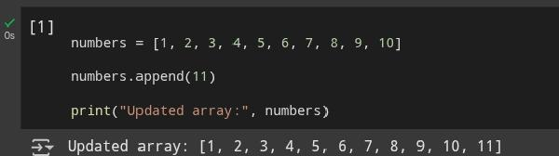

Figure 2

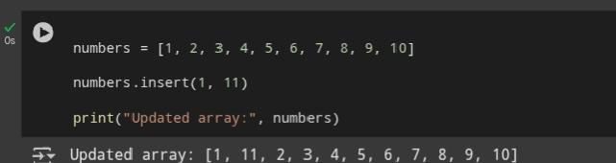

Figure 3

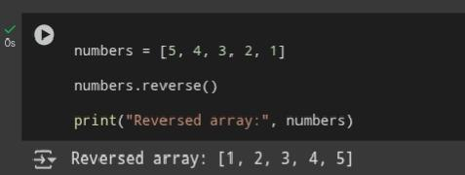

Figure 4

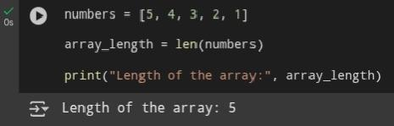

Figure 5

# Conclusion

Creating and displaying lists, accessing elements via indexes, altering lists with append and insert, transforming lists using reverse and sum calculations are all covered in this exercise. These fundamental abilities provide a solid foundation for working with increasingly complex data structures in the future and are essential for data manipulation and Python application development.

**References**

[1] A. Markaran, E. Melnikov, and A. Sumich, “Basic Operations with Lists,” May 03, 2024. <https://sg-link.byteoversea.com/?aid=489823&lang=en&scene=im&jumper_version=1&target=https%3A%2F%2Fdiveintopython.org%2Flearn%2Fvariables%2Flist%2Fbasic-operations%3Fneed_sec_link%3D1%26sec_link_scene%3Dim&theme=light>

[2] P. Pedamkar, “List operations in Python,” EDUCBA, Jul. 04, 2023. <https://sg-link.byteoversea.com/?aid=489823&lang=en&scene=im&jumper_version=1&target=https%3A%2F%2Fwww.educba.com%2Flist-operations-in-python%2F%3Fneed_sec_link%3D1%26sec_link_scene%3Dim&theme=light>